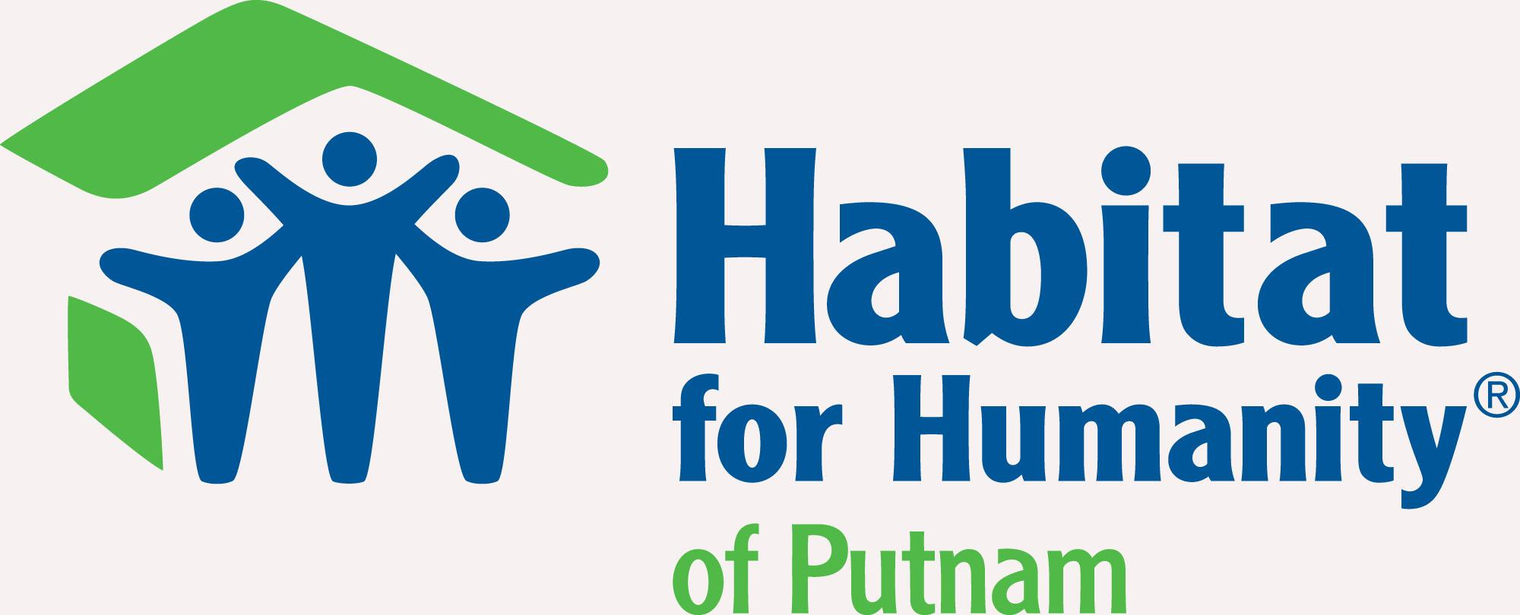

Contact: Murali Thirumal FOR IMMEDIATE RELEASE

Phone: (706) 991-1600 October 22, 2020

Email: putnamcountyhabitat@gmail.com

**Putnam County, GA** – Hard work is an attributing factor most people know they need possess to achieve their goals. Doing the bare minimum is not a motto in which Habitat for Humanity is familiar with. They go the extra mile to ensure homes are provided to families and in return they expect the same. To provide for a family is not a bare minimum task and those who apply for a home know that hard work is a key factor they must possess.

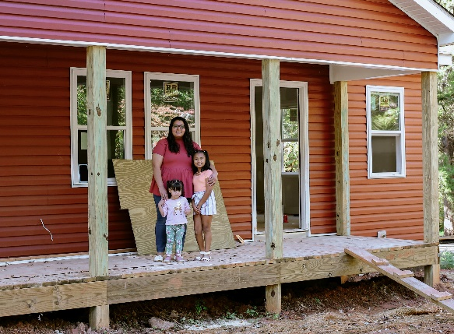The Meraz Family are the 2020 recipients of a remodeled home provided by Habitat for Humanity, Putnam. Luz Meraz and her daughters are ecstatic about the upcoming change that will impact their family for the rest of their lives.

Being no stranger to hard work, Luz has worked in the banking industry within Putnam County since graduating high school in 2016. She currently works at a local bank in Eatonton to support her daughters, Melanie (7) and Dalilah (2), who will also be living in the new house.

When Luz is not working, she volunteers her time coaching a soccer team for the Putnam County Recreational Department as well as volunteering at the Habitat ReStore in Greensboro and at various build sites for other families receiving a home. She elaborated with, “Anytime they need me to come help clean up or help out at the house, I come and help clean up.”

Luz is no stranger to Habitat for Humanity though. When asked how she came about applying for a home from Habitat, she responded, “My sister actually received a remodeled Habitat home, and before then we did not think it was a possibility for us.”

After seeing her sister’s success with Habitat, she needed little convincing to submit an application for her own family. “When my sister took in her application and they ended up granting her for a house, she told me that I should go ahead and apply. They are REALLY nice people,” she exclaimed.

The Meraz Family are now among the pool of those who have seen the positive benefits of what Habitat for Humanity has to offer. Knowing now that the hard work will continue, she still continues to be appreciative of all that Habitat has provided for her family. “Initially, we all thought Habitat was something way different than what it actually was; a lot of people think it’s a free house but they are just helping you pave your way into something new and that is amazing,” said Luz.

ABOUT HABITAT FOR HUMANITY PUTNAM COUNTY, INC.

Habitat for Humanity Putnam County, Inc., founded in 1997, is described as a nonprofit organization that relies on volunteer efforts to save costs of labor when building homes. Each year, qualified individuals will complete an application in hopes to be selected for one of two houses that are built in Putnam County annually.

For more information: www.putnamcountyhabitat.org