Contact: Murali Thirumal FOR IMMEDIATE RELEASE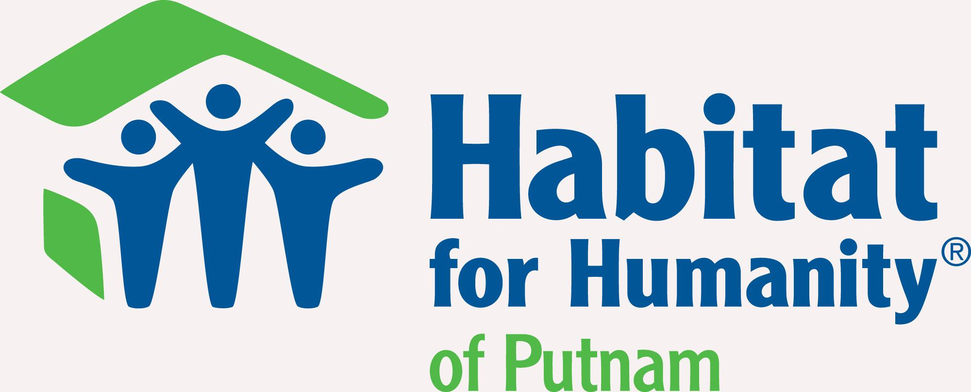

Phone: 706-991-1600 September 18, 2020

Email: putnamcountyhabitat@gmail.com

Putnam County, GA – If there is anything history has taught us is that the journey of an American immigrant is not an easy one. Trying to find stable work, getting adequate housing, and maintaining steady income while all in a foreign land prove the hardships of an immigrant to be a collective struggle that most if not all have. Habitat for Humanity is known to provide affordable housing and resources to those in need but Habitat has a stance that triumphs all –diversity.

The Sanchez Family are the 2019 recipients of a home provided to them by Habitat for Humanity Putnam County, Inc. Rosando and Estela Sanchez are looking forward to finally getting the home they have always hoped for 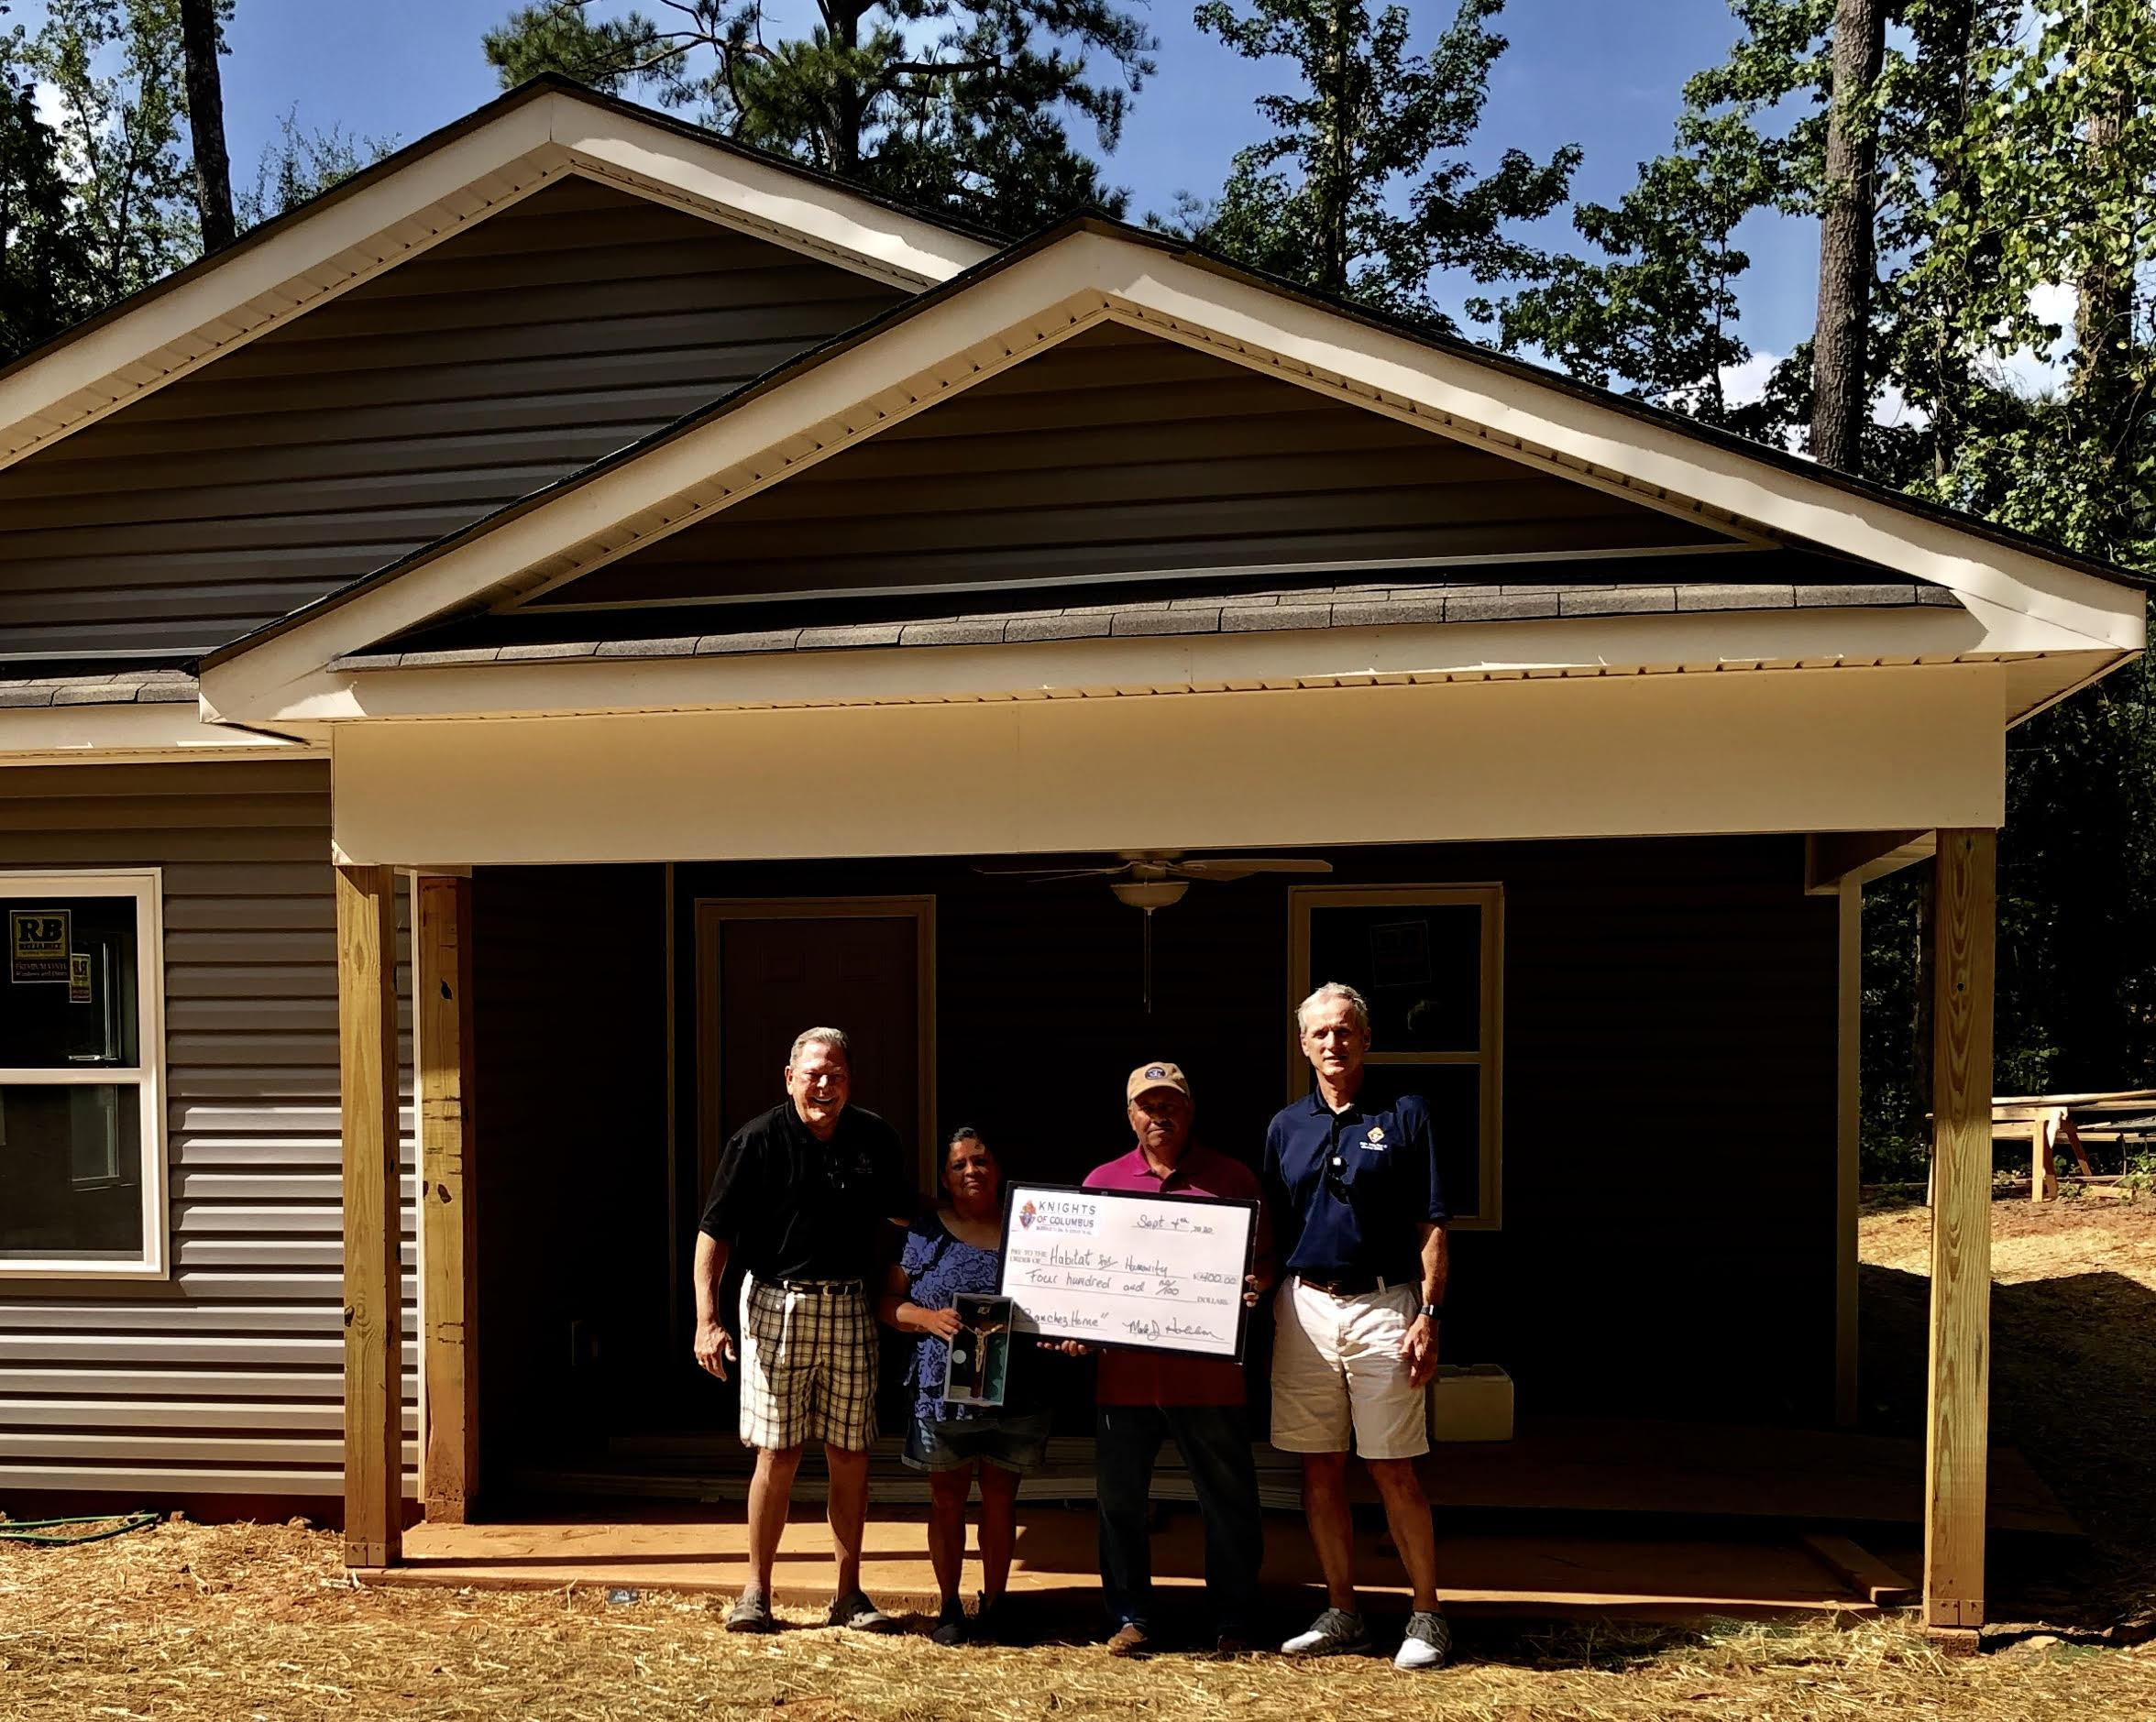since immigrating to the United States.

Rosando came to America in 1992 to work on a dairy farm in Texas and Estela followed him in 1997. Together they have four children, with their youngest Cristina attending Georgia College & State University part-time. She will also be living in the Sanchez Family’s new home once completed.

The family is quite active in volunteer work throughout Putnam County. Estela provides food for crews at work sites while Rosando works with his

|  |
| --- |
| Sanchez Family receiving $400 donation from Knights of Columbus |

friend’s local roofing company. Both of them currently work at the Putnam County ReStore where they perform various duties such as cleaning, sorting and selling items.

The Sanchez family are members of Christ Our King and Savior Catholic Church in Greensboro, GA as well as the affiliated Knights of Columbus Council 13808, where they support a broad array of local charities, including Habitat for Humanity Putnam County, Inc., through service hours and other fundraising efforts.

When we asked Estela her biggest challenge in meeting the volunteer requirements, she replied with, “Oh, it’s not been a challenge! I enjoy meeting all the people. I really like that I’m meeting and helping people; it’s been so much fun.”

Like most applicants, the Sanchez family was initially reluctant about applying for a home with Habitat. “We were so anxious about applying; we always put it off. Finally, my sister Marie got the application and we gathered all the documents. There’s a lot more to applying than just filling out an application; we worried at first that it might not work out,” said Cristina.

Of all the 85 applicants for the 2019 year, they were accepted quickly as the recipients.

After asking Estela the best thing about being accepted, without hesitation she responded, “I can finally be calm! I no longer will worry about where we will live. No more moving; finally settled!”

The Sanchez Family can now include themselves as one of the many of families positively impacted by Habitat for Humanity Putnam County, Inc. Their new home will give them the start that they have wanted. “We never would have owned our home if it weren’t for Habitat for Humanity,” said Estela.

ABOUT HABITAT FOR HUMANITY PUTNAM COUNTY, INC.

Habitat for Humanity Putnam County, Inc., founded in 1997, is described as a nonprofit organization that relies on volunteer efforts to save costs of labor when building homes. Each year, qualified individuals will complete an application in hopes to be selected for one of two houses that are built in Putnam County annually.

For more information: www.putnamcountyhabitat.org